PUBLIC NOTICE OF A POLICY COMMITTEE MEETING OF
THE GALE-ETTRICK-TREMPEALEAU SCHOOL DISTRICT

PUBLIC NOTICE is hereby given to the public and the news media pursuant to Wisconsin State Laws that a POLICY COMMITTEE meeting of the School Board of Joint School District No. I of the City of Galesville, Villages of Ettrick and Trempealeau, and Towns of Dodge, Caledonia, Ettrick, Gale, and Trempealeau in the County of Trempealeau and Town of North Bend in Jackson County, Wisconsin, will be held on Thursday, August 4, 2022, commencing at 6:00 p.m. at the G-E-T High School Library in the City of Galesville, Trempealeau County, Wisconsin, and the preliminary agenda for said meeting is as follows:

- Call Meeting to Order
- Roll Call of the Board
- Proof of Public Notice
- Approval of Minutes
- Review Policies 200S
- Adjournment

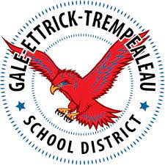

A quorum of Gale-Ettrick-Trempealeau School Board members
may be present, but no board action will be taken.

